34.14: a) 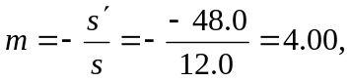where 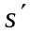comes from part (b).
b) 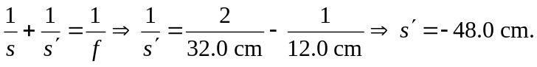Since is negative, the image is virtual.
c)

